MiniProject Report on

“COURSE MANAGEMENT SYSTEM”

Submitted by

Nikhil Deshmukh (3164022)

Jayant Choudhari (3164017)

Sachin Devangan (3164025)

Prathamesh Jagtap (3164042)

Under the Guidance of

Prof. Anjali Shejul
Prof. Pradnya Kulkarni

At


DEPARTMENT OF INFORMATION TECHNOLOGY
MIT College of Engineering

PUNE – 411038

[October 2018]

Affiliated to



SAVITRIBAI PHULE PUNE UNIVERSITY
Date:
CERTIFICATE

This is to certify that,
- Nikhil Deshmukh (3164022)
- Jayant Choudhari (3164017)
- Sachin Devangan (3164025)
- Prathamesh Jagtap (3164042)

of class T.E IT have successfully completed their mini project work on “Course Management System” at MIT College of Engineering, Pune in the partial fulfilment of the Graduate Degree course in T.E at the department of Information Technology, in the academic Year 2018-2019 Semester – I as prescribed by the Savitribai Phule Pune University.

------------------------------ ---------------------------

Prof. Anjali Shejul Prof. Pradnya Kulkarni

------------------------------
HOD, Information Technology

Acknowledgements

We would like to express our deepest appreciation to all those who provided us the possibility to complete this report. We would like to give special gratitude to our guide and teacher, Prof. Anjali Shejul, Prof. Pradnya Kulkarni whose contribution in stimulating suggestions and encouragement helped us to coordinate this project especially in writing this report and for investing her full effort in guiding our team in achieving the goal.
Furthermore, I would also like to acknowledge with much appreciation the crucial role of the staff of MIT College of Engineering, who gave us the permission to use all required equipment and laboratories to complete our project on Course Management System.
A special thanks goes to our Head of Department and the Principal who gave us the golden opportunity to do this wonderful project which also helped us in doing a lot of Research and we came to know about so many new things so we are really thankful to them.
Lastly, we would also like to thank our parents who helped us a lot in finalizing this project within the limited time frame.

Jayant Choudhari (3164017)
Nikhil Deshmukh (3164022)
Sachin Devangan (3164025)
Prathamesh Jagtap (3164042)

CONTENTS

Abstract
- Introduction
  - Brief Introduction…………………………………………7
  - Purpose of project…………………………………………7
  - Objectives…………………………………………………8
  - Users of the system………………………………………..8
- Scope……………………………………………………………9
3. Software/hardware Requirement Specification……………..10
4. E R diagram……………………………………………………11
5. Relational Database Design……………………………………13
6. Data Normalization…………………………………………….16
7.Graphical User Interface……………………………………….17
8. Testing…………………………………………………………...23
9.Conclusion………………………………………………….........25
10.References……………………………………………………....26
ABSTRACT

The purpose of Code-X is to automate the existing manual system of online course management system by the help of computerized equipment and full-fledged website, fulfilling their requirements, so that customer can easily learn the different courses provided by us.
Code-X, as described above, can lead to error free, secure, reliable and fast learning of courses. It can assist the user in learning the courses at our website. That means that one need not actually to visit another website to learn other courses.
The project report describes how the website is going to work, and how it will ease the process of learning the courses online. It will put some light on the basics of creating the website, and also the steps involved in doing that.

Chapter 1

1.1 Introduction
Course management system developed to Managing a large course is a complex task. Many factors may contribute to this complexity: many students; a course staff including several roles such as instructors, teaching assistants, staff assistants, and graders; both individual and group assignments; formation and disbanding of student project groups during the course; large, multipart assignments whose grading may be partitioned across problems, across recitation sections, or both; large student assignment submissions comprising many ﬁles; student requests for regarding tracking the progress of these various steps and notifying students where appropriate.
This software is supposed to eliminate and, in some cases, reduce the hardships faced by the customer in the manual system. The application is optimized to avoid errors while entering data. For this, error messages are provided on entering invalid data. The user does not need to have any technical or programming knowledge to use this website. It also has an attractive GUI designed by keeping in mind the concepts of Human-Computer Interaction.
In this document, the architecture, working, flow, and steps of the process of building the website have been discussed. Also, the future possible ventures are talked upon. Requirement analysis and SRS is also included, along with test cases. The aim is to provide a better understanding of the website, its working, and the implementation.

1.1 Purpose

The aim of this document is to specify complete description of the “Course Management System”. Through this document, the workload needed for Course Management System website development, validation and verification will ease. To be specific, this document is going to describe functionality, performance, attributes and the design constraints. Therefore, intended reader groups for this software requirement specification are users, admins and organizer.
The purpose of this document is to present a detailed description of the open-source software. It will explain the purpose and features of the software, the interfaces of the software, what the software will do and the constraints under which it must operate. This document is intended for users of the software and also potential developed.

1.3 Objectives:
1. To study the functions of Course Management System.
2. To explore the challenges being faced by the manual system.
3. To make a software fast in processing, with user friendly interface.
4. To ensure accurate user data being provided related to their details.
5. User will be able to use the system easily and can participate eventually.

1.4 Users of The System
- Student: Student can login in student login & can select course, enquire about all courses, faculty, etc.
- Teacher: Teacher can login in teacher login & can create, update, delete batches.

Chapter 2
2. Scope
The product to be produced is intended for the inquiry and registration for course which is suitable and important for him. This process will be carried out by the website.
- The user has to search proper course from our list which will be suitable for his/her experience.

- The main goal is to facilitate easy inquiry and selecting of a course, for any customer who accesses the website. This will prove to be very useful because the number of options in courses is large, and the automation of the process of inquiry can help the customer to find the best course to learn in minimum time.

- Teacher’s job also becomes easy as he/she don’t need to take more efforts to find students, to inform individual student about changes in batch, etc.

Chapter 3
Software/Hardware Requirement specification
Software Requirements
Server Side :-
Operating System | Windows 2003 Server
Server | Apache (PHP5, MySql5.5.34)
Browser | Internet Explorer 6.0 or Compatible Web Browser
Client Side:-
Operating System | Windows XP or Equivalent or Linux
Browser | Internet Explorer 6.0 or Compatible Web Browser
Hardware Requirements
Server Side:-
Processor | 2.3 GHz or above
RAM | 512 MB
Hard Disk | 10GB

Client Side:-
Processor | 1.6 GHz or above
RAM | 512 MB
Hard Disk | 1GB

Chapter 4 E R diagram
Entity Relationship Diagram
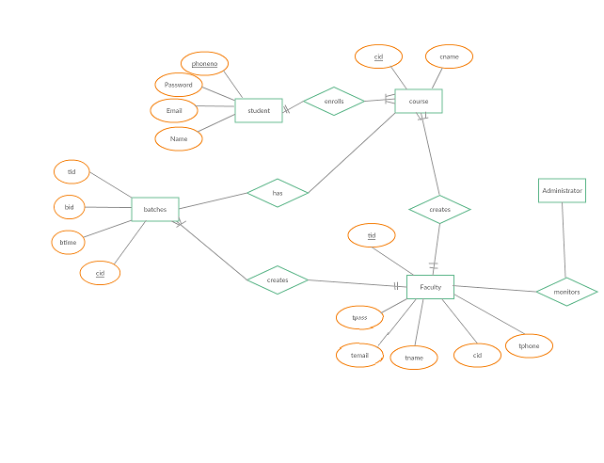

Chapter 5
Relational Database Design
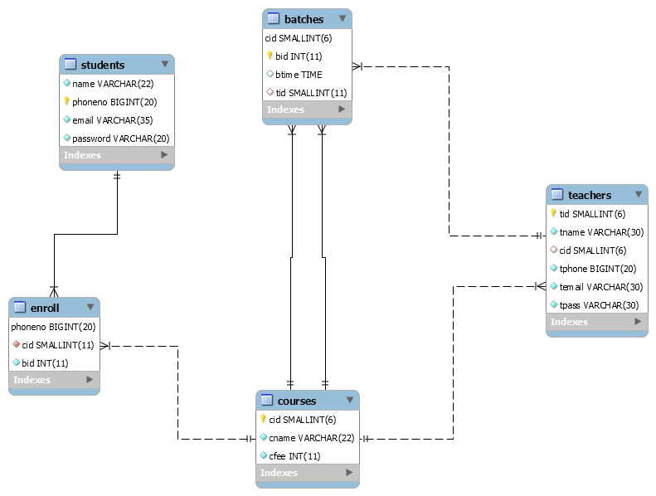

Chapter 6 Data Normalization

Here are the most commonly used normal forms:
- First normal form(1NF)
- Second normal form(2NF)
- Third normal form(3NF)
- Boyce & Codd normal form (BCNF)

- First Normal Form:
As per First Normal Form, no two Rows of data must contain repeating group of information i.e each set of column must have a unique value, such that multiple columns cannot be used to fetch the same row. Each table should be organized into rows, and each row should have a primary key that distinguishes it as unique.
This condition is satisfied as there is primary key in the tables, for each row having unique value.
- Second Normal Form:
As per the Second Normal Form there must not be any partial dependency of any column on primary key. It means that for a table that has concatenated primary key, each column in the table that is not part of the primary key must depend upon the entire concatenated key for its existence. If any column depends only on one part of the concatenated key, then the table fails Second normal form.
In students table, if we make phoneno a primary key {emailid,Password , student name} then all the remaining non-key attributes will depend on phoneno key completely.

- Third Normal Form:
Third Normal form applies that every non-prime attribute of table must be dependent on primary key, or we can say that, there should not be the case that a non-prime attribute is determined by another non-prime attribute. So this transitive functional dependency should be removed from the table and also the table must be in Second Normal form.
In our tables, there is no transitive dependency as each non-prime key completely depends on primary key

Chapter 7
Graphical user interface
Home
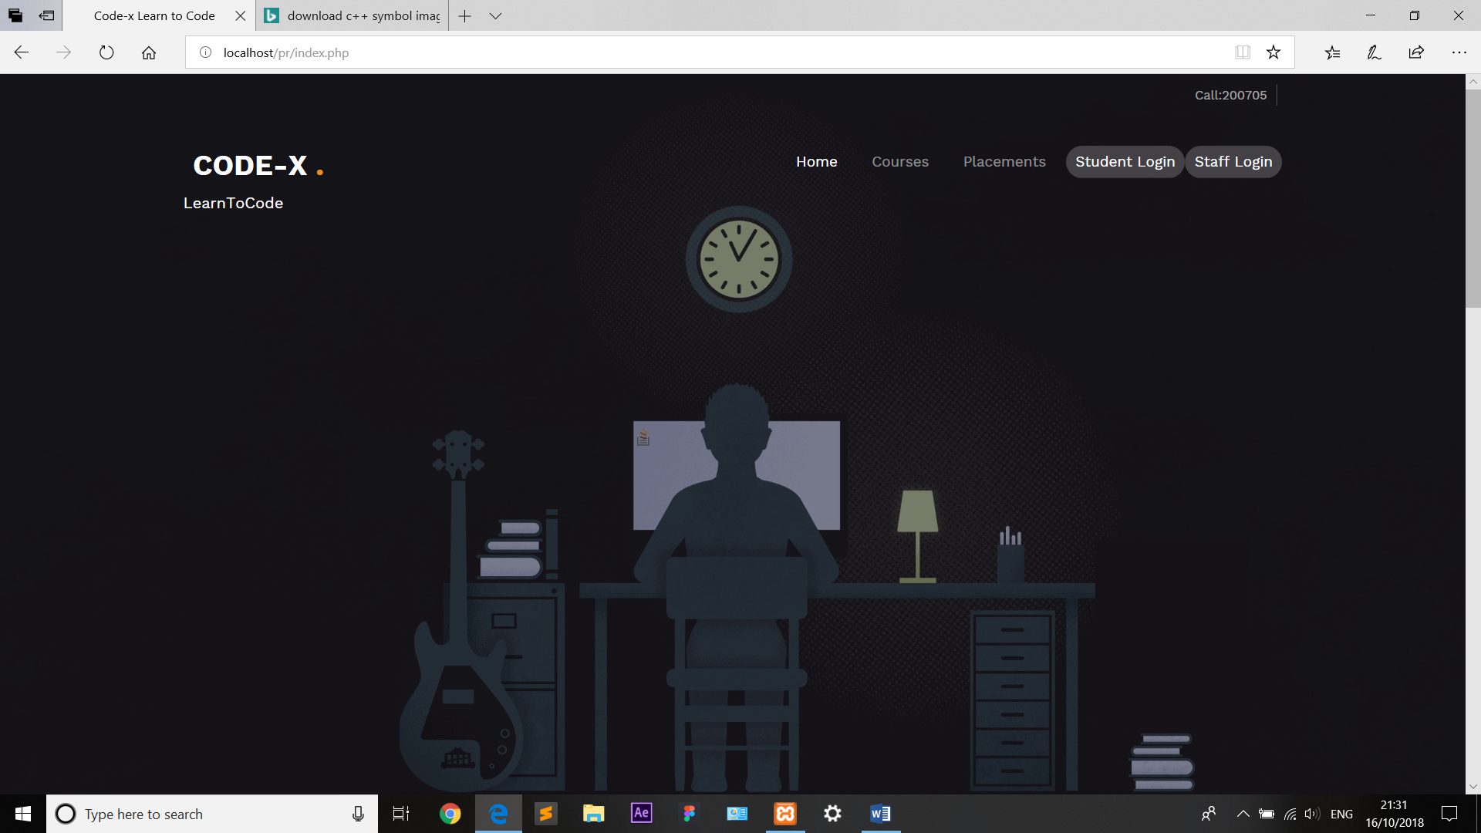





Student Login:
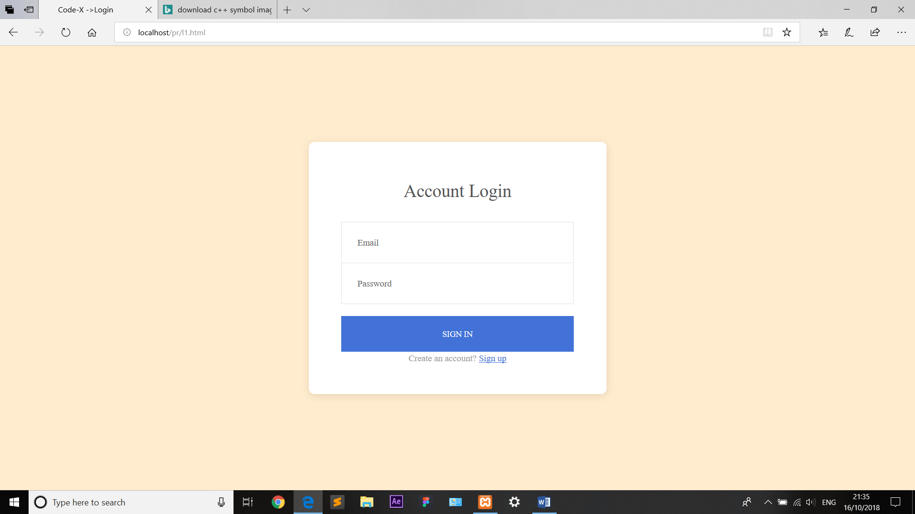

Student Registration:
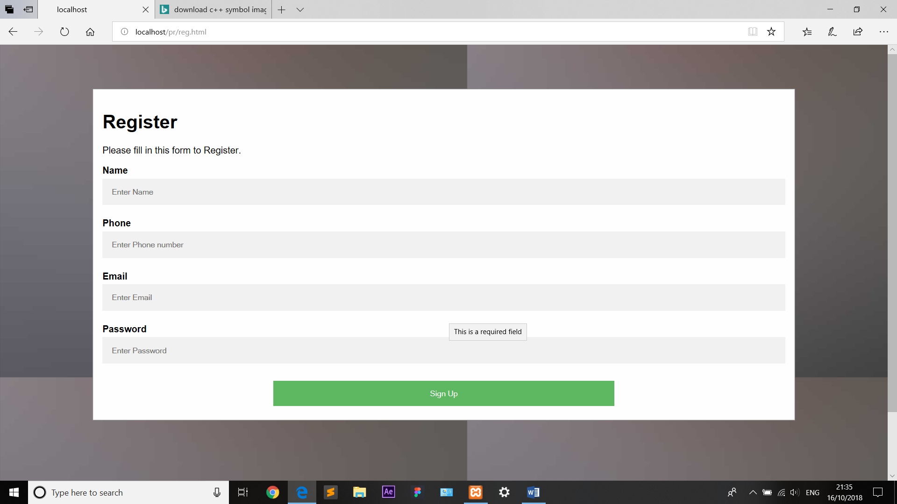

Student Profile:
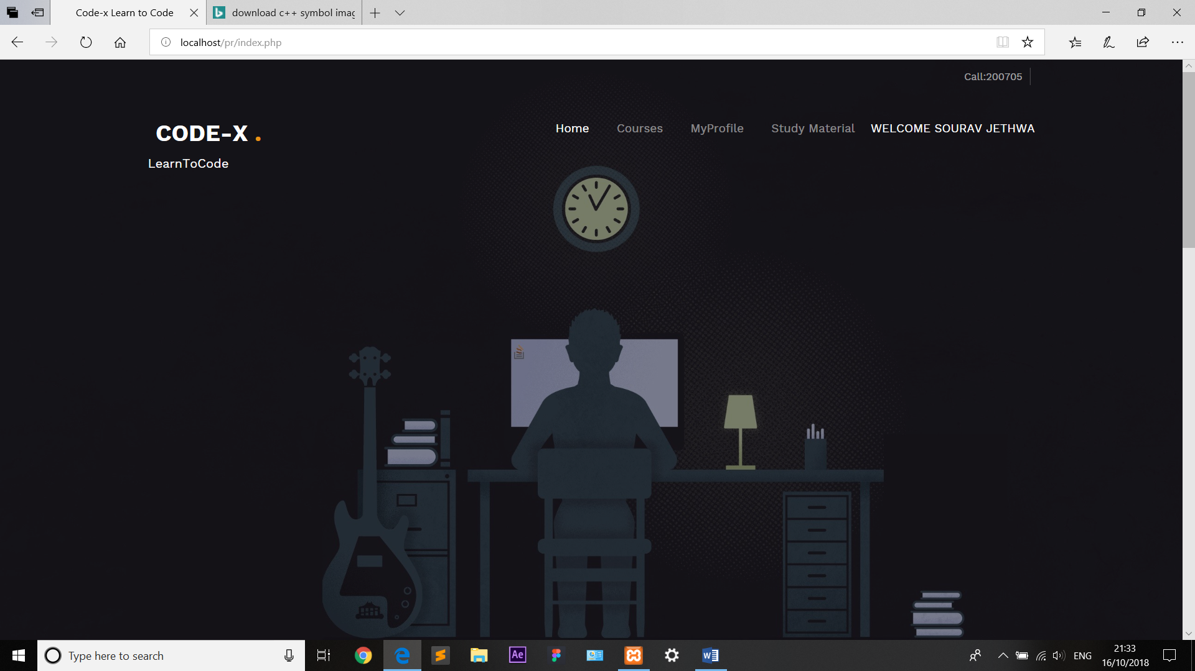

Teacher Login:
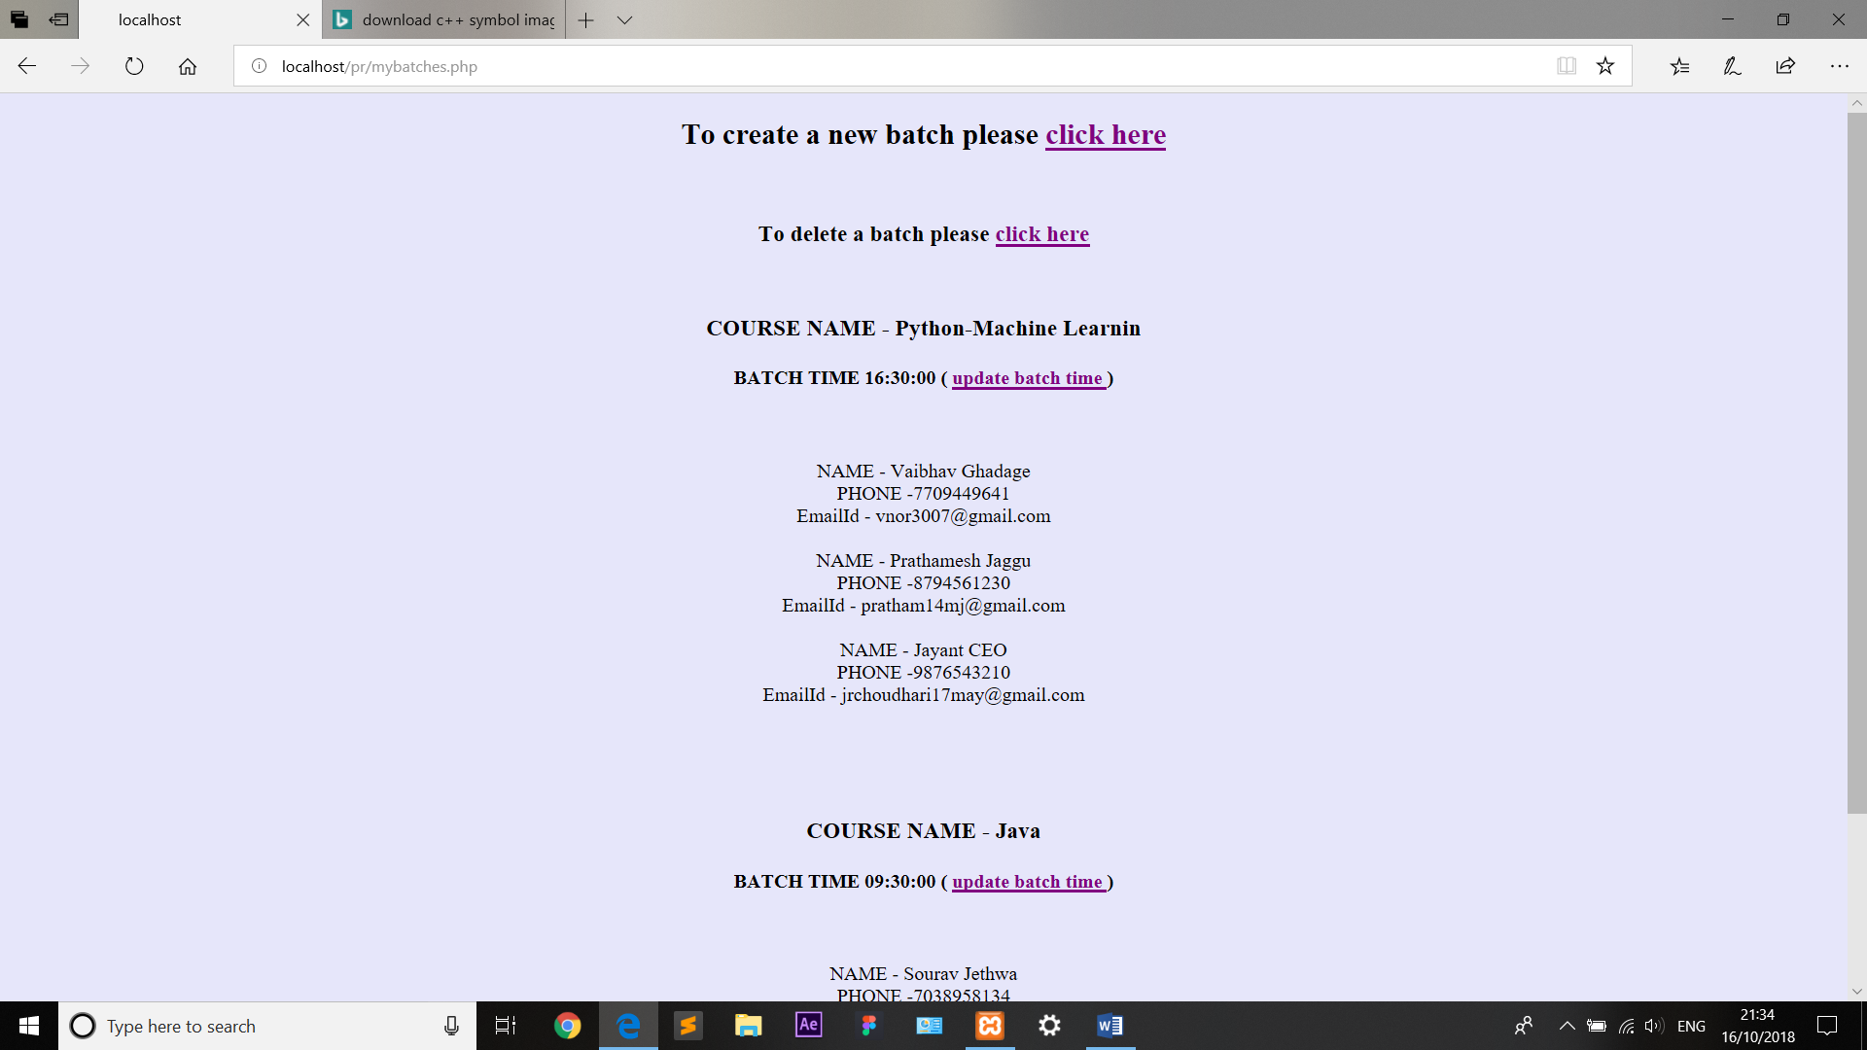
Chapter 8
Testing

9.1. Test scenario

Sr.  No | Page | Action | Inputs | Actual Output | Expected Output | Result
1 | Home page | Launch application | Localhost:85/pr/index.php | Home page  of  CODE-X | Home page  of  CODE-X | pass
2 | Log in | Enter invalid  Email & any Password and hit login button | Email :1231564.com  Password: ****** | Enter Correct Information | Enter Correct Information | pass
 |  | Enter valid email & incorrect Password | Email: valid@gmail.com  Password: ****** | Enter Correct Information | Enter Correct Information | pass
 |  | Enter valid Email &  correct Password | Email: valid@gmail.com  Password: ****** | Successfully log in->  Home page | Successfully log in -  >Home page | pass
3 | Create new batch  (Teacher) | Valid course id and valid batch id | Course id ,Course name and Batch id | Batch created successfully | Batch created successfully | Pass
4. | Delete a Batch | Select a batch to delete | Select Batch id and Batch name | Batch deleted  Successfully | Batch deleted  Successfully | Pass
5. | Update Batch Time | Enter Batch Time | Enter Valid Batch time | Batch Updated Successfully | Batch Updated Successfully | Pass

6. | Register | Enter invalid name and hit submit button | First name:123 | Enter correct name. | Enter correct name. | pass
 |  | Invalid Ph.no/Email address and hit submit button | Ph.no: asb  Email:456 | Enter valid ph.no | Enter valid ph.no | pass
 |  | Invalid email and hit submit button | email:111 | Enter valid EmailId | Enter valid EmailId | pass
 |  | Enter Valid Information | Enter Valid Information | Account created Successfully.  Now login | Account created Successfully.  Now login | pass
Test1:
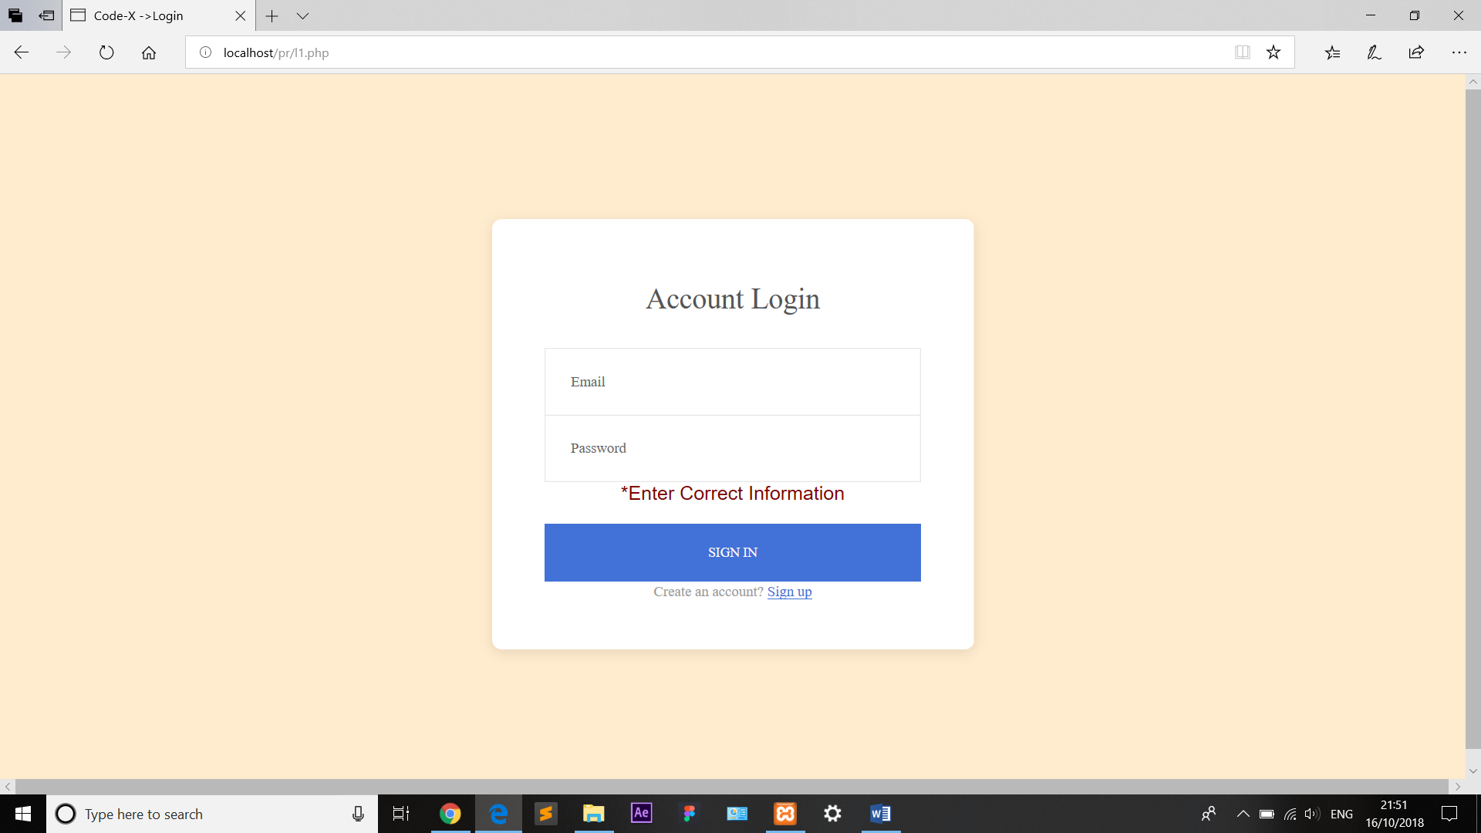
Test2:
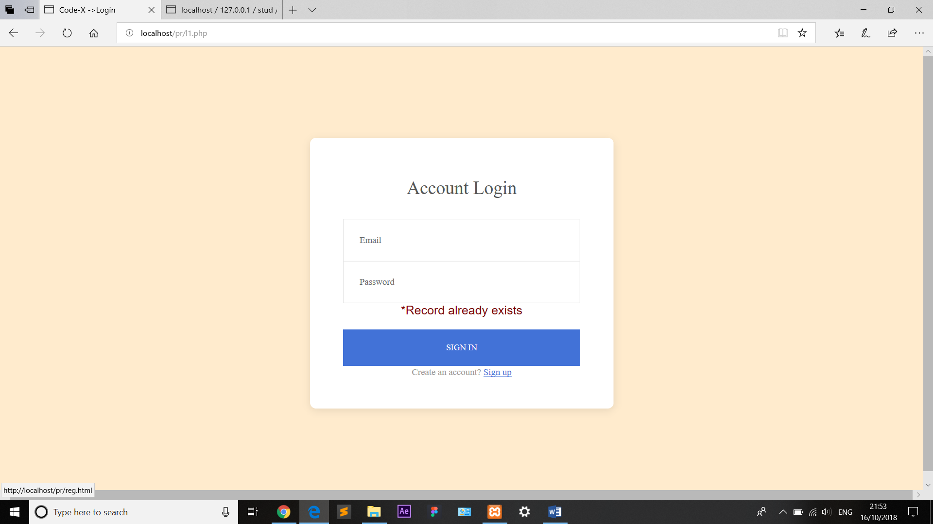

Test3:
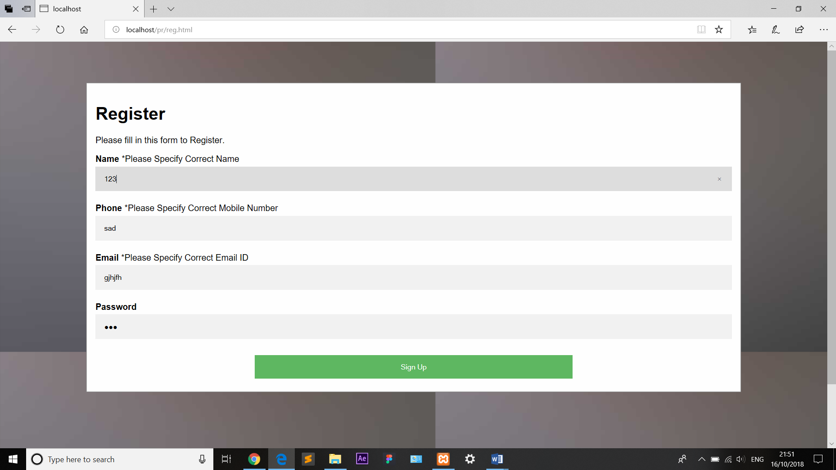

Chapter 9 Conclusion
The technologies cover the fundamental role of connector between the physical world and the world of information, in order to amplify the knowledge but also and especially the enjoyment.
- From this project we have studied and implemented the following work

- To develop any website
- To design any website
- HTML, CSS, JS
- To use CMS tool
- To use/learn Apache server
- To use/learn MySQL server
- To use of XAMPP
- To use of Joomla!
- Form validation using PHP
- Hosting any website
- Users perspective about any website
- UI/UX interface
- GUI interface

Chapter 10
Reference
WEBSITES:
- https://www.tutorialspoint.com
- https://www.w3schools.com
- https://www.slideshare.net/KrishnasaiGudavalli/software-requirements-specification-17173967
- https://www.academia.edu/28878626/ORPHANAGE_MANAGEMENT_SYSTEM
- https://www.apachefriends.org/download.html
- https://www.savethechildren.in/
- YouTube tutorials
  - http://www.youtube.in
- Google
  - http://www.Google.com

